Principal Component Analysis

What is it

Dimension reduction

Igen Value and Vector

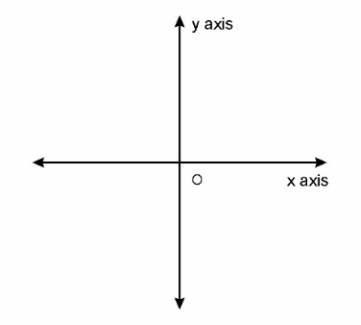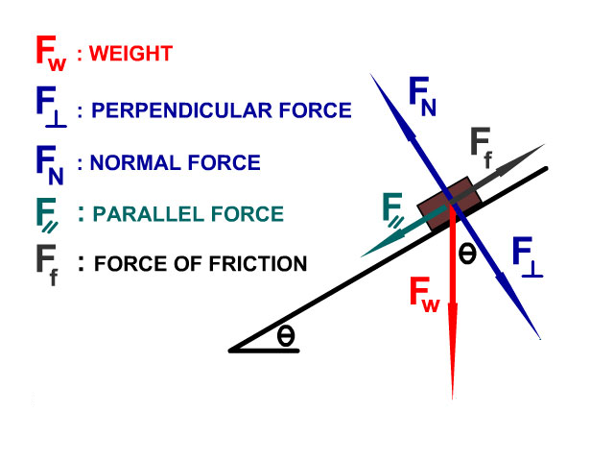

* Fw: Weight of the object that is Straight Down
* F⟘ : Perpendicular component of Force that is pushing into the incline plane
* F⸗ : Parallel component of Force that is parallel to incline plane.
* FN : Normal Force that is the equal and opposite to F⟘
* Ff : Force of Friction is in opposite direction to object movement.
* Ө : Angle of Incline